|  |  |
| --- | --- |
| **Full Name** | Akila Deshan Maithripala (University of Colombo School of Computing) |
| **National ID Number** | 993501123V |
| **Contact Number** | 071-3476970 |
| **Candidate Number** |  |

1. **What is “Story Points” in Agile?**

A unit of measurement in Agile. It’s measured to have an estimation of the effort needed to implement a piece of work during a work cycle.

1. **Write a user story to schedule a Medical Appointment in an Online Channeling App.**

Title: Schedule a Medical Appointment:

As a registered user logged into the app,

I want to schedule a medical appointment with a doctor from a list I can choose, at a time that is feasible,

And pay via my bank card.

So, that I can visit the doctor at the scheduled time and place, after paying the amount.

Display: Available Doctors, Date, Time to choose from

Calculate and Display: Fee and then Payment options

Display error message if not feasible.

Acknowledge user if the doctor is unavailable after the appointment is placed.

Notify user before the appointment as a reminder.

1. **"The teams following the Agile Methodology can always perform better than the teams following other Software Development Methodologies." State your arguments about this statement whether you accept it or not.**

Agree with the statement.

Agile methodology provides a flexible work standard that is created in a flow like process to let the employees work in a dynamic environment. Unlike procedural methods like waterfall method where a one team’s task is finished after one stage, Agile unites the whole workspace to work collaboratively on the project in cycles hence, increasing the understanding the of the work more and lets the employees bring more ideas and perform better at the project.

Also the employees feels the automation of the process, and that makes it easy to manage the groups as after few cycles, they gets the hang of it and carries out the work productively.

1. **List down the UML Diagrams widely in use. Briefly explain the listed diagrams and give one example of any of them.**

* Class Diagram
  + Acts as major building block object oriented solution. This diagram shows the classes the system has and their attributes and operation and importantly the relationship between classes.
* Component diagram
  + Shows the structural relationship of components in the system. Useful when the system has multiple interrelated components.
* Use case diagram
  + Shows a graphical overview of the actors involved and functions needed by them and how the functions relates with each other.
* Activity Diagram
  + Represent workflows in a graphical way. Used to show the business and operational workflow of components.
* Package diagram
  + Shows the dependencies between different packages in a system.
* Sequence Diagram
  + Shows how interactions between objects and the order of those interactions for a scenario.
* Timing Diagram
  + Shows the behaviour of objects in a given time frame.
* Deployment diagram
  + Shows the hardware and the software in that hardware

1. **Draw wireframe for the user journey of Shopping Cart functionality to use in an online shopping mobile app consisting all needed functionalities. Also, briefly explain the functional elements of the wireframe.**

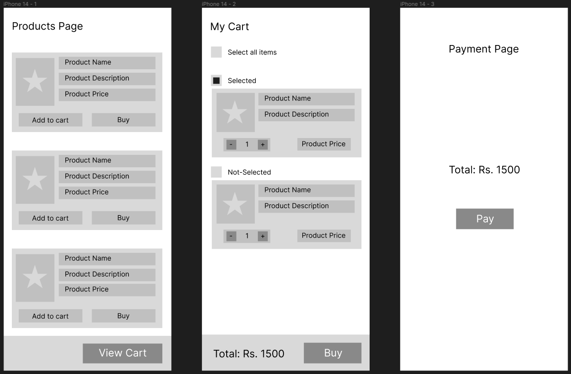

1. Products page – Which the user can browse items and then add them to cart.
2. Cart – User can select the items they want to purchase, and then proceed to buy. Total amount is also shown.
3. Payment – When ‘Buy’ is clicked, user is directed to the payment page where they can add a payment method and proceed buying the items.
4. **Suggest a suitable business model with the most required features/modules to consider with the mobile app. State some unique features separately to simplify and enhance the end-user experience to facilitate them to use this app without much struggles.**

* A two-sided marketplace platform app (Uber like application)
* Involved actors are the farmers who produce crops and vehicle owners who can deliver.
* Basic functions are that,
  + Farmers should be able to notify that they are in need of a vehicle.
  + Vehicle owners should be able to tell that they are available for a transportation job.
  + Calculate and show the fare.
  + Calculate and show the time,
    - For a vehicle to reach the farmer
    - To reach the needed place after loading
* Nice to have facilities
  + Save the frequently used vehicle owners.
  + Encourage both actors by providing a point system that earns them points as they use the app more and in a systematic way.
  + Map functionality to show them where each other are.